WEEK 1 NET731 Practical’s

TASK 1
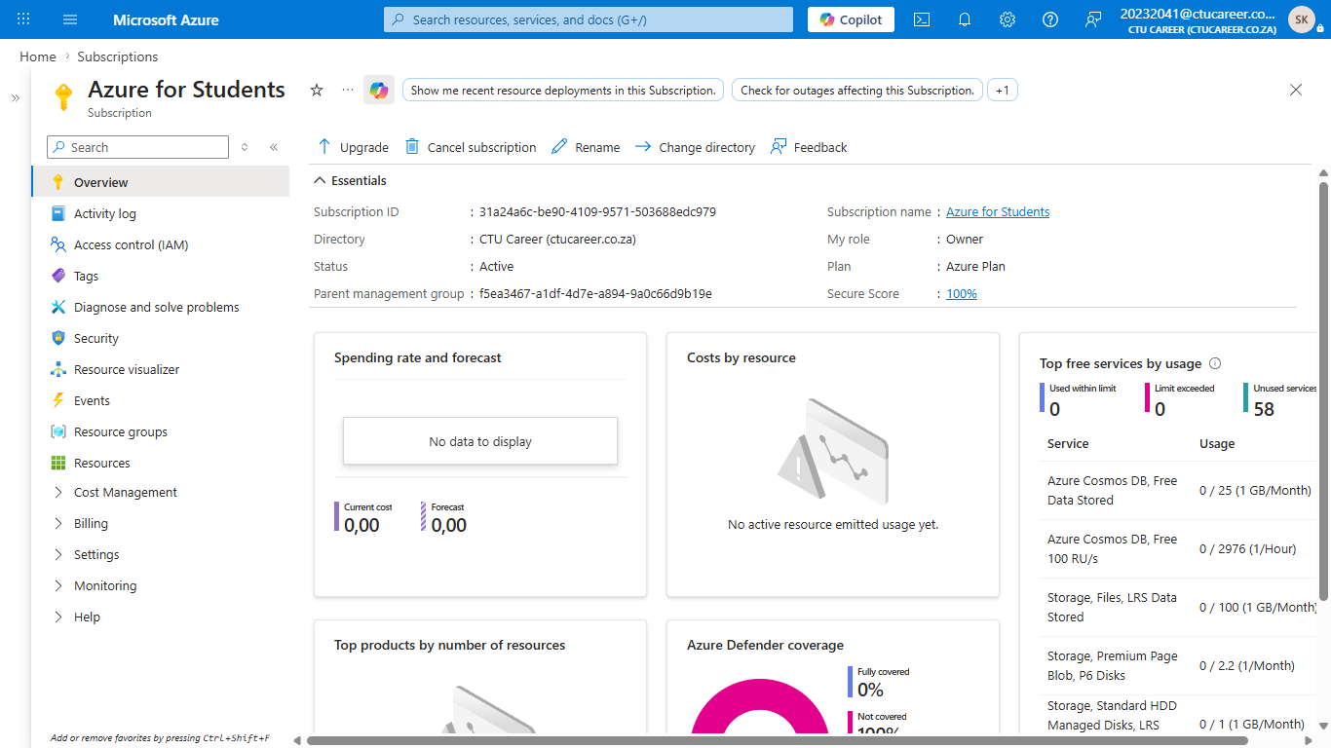

TASK 2
Business Requirements for CTU Training Solutions
CTU Training Solutions provides IT, Engineering and Business courses online and contact.
The progress and results of student is stored securely.
The facilitators must manage courses, assignments, and student access efficiently.
The resources must be scalable.

TASK 3
Azure Service | Purpose / Why you need it | Week it is used
Resource Group | Used to organize and manage Azure resources in one container. | 1
Virtual Network (VNet) | Provides private network communication between Azure resources. | 1
Virtual Machine (VM – B1s) | Provides a low-cost virtual server. | 2
Microsoft Entra ID | Manages user identities, authentication, and access control for Azure resources and services securely. | 2
Network Security Group (NSG) | Controls inbound and outbound network traffic. | 3
Azure Storage Account | Provides secure cloud storage. | 3
Microsoft Defender for Cloud | Monitors security and provides recommendations to improve cloud security and compliance. | 4
Azure Monitor | Collects and analyses logs, metrics, and performance data. | 4
Azure Cost Management | Help track, analyse, and optimize Azure spending. | 5

TASK 4
Azure Resource Groups
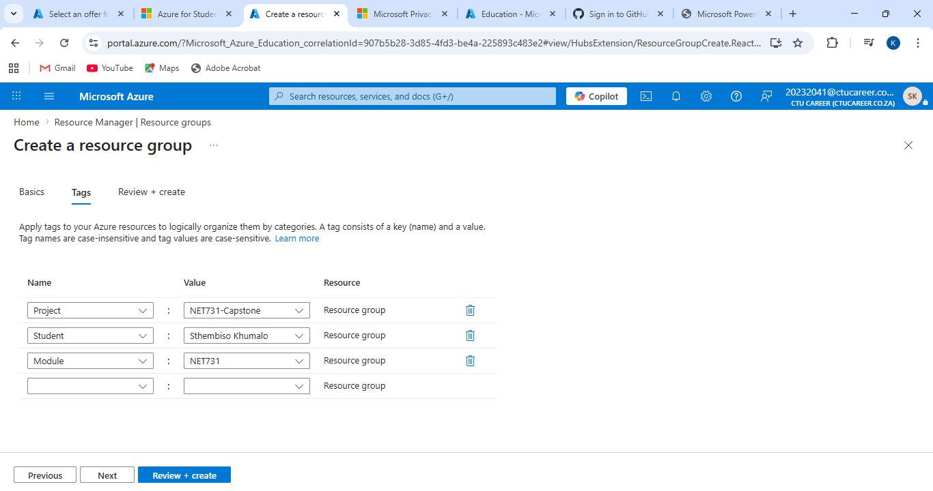

Tags
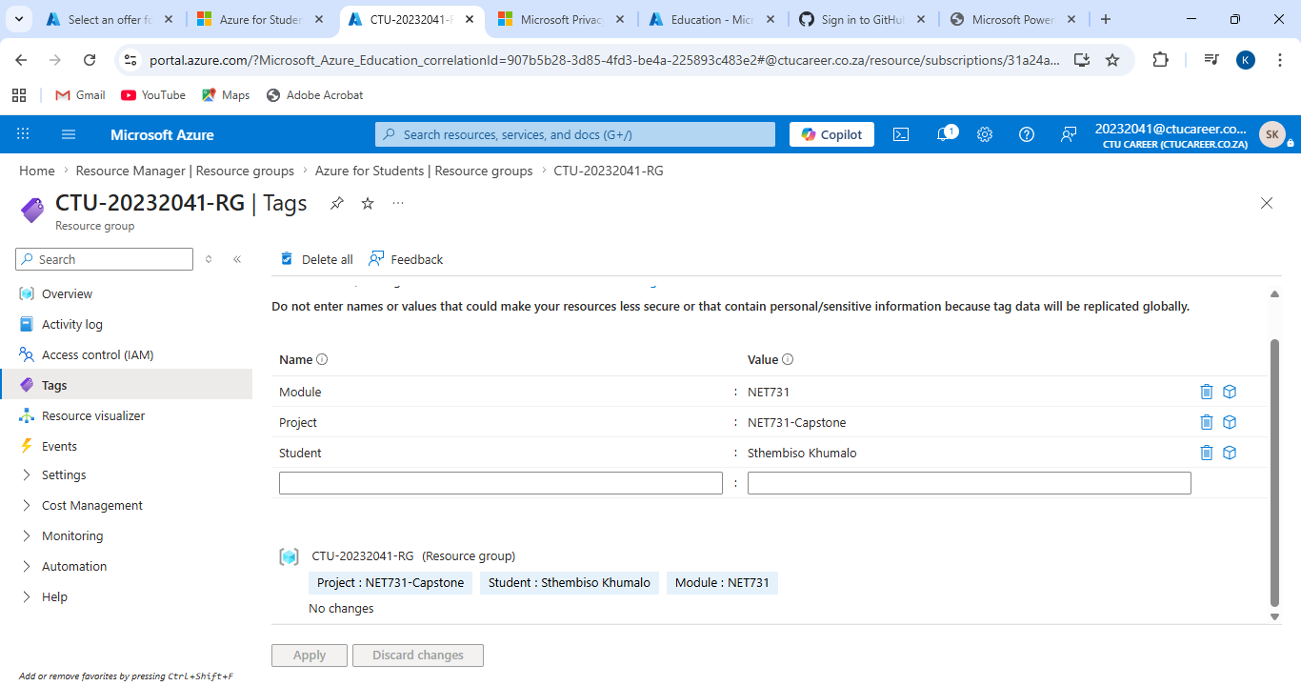

Review and create
